**Component Selection**

Specification (such as voltage, current rating), dimensions and availability are important to select components. Firstly, we determined the components to use. Then, the specification of the components can be determined by considering the result of the computer simulations.

For the AC to DC converter, 6 discrete diodes or 3-phase rectifier module can be selected. 6 discrete diodes can be more modular due to easily changing diodes independently. However, the rectifier module places smaller area. We choice the three-phase rectifier module to make the project smaller. Also, the rectifier operates at 220 V DC output with full load drawing 7 A. Thus, the voltage and current ratings are chosen in safe region.

* Three-Phase Diode Rectifier Module (20 A, 400 V)

For the DC Link Capacitor, the 800 micro farad capacitor is required to make the ripple smaller. The capacitor operates at 220 V. Also, two capacitors with parallel is cheaper than one capacitor. Also, ESR value is taking consideration. İt can be low to fast response.

* Capacitor(470u,400V), Capacitor(330u,400V)

Motor driving has controller and gate driver with transistor and diode. The controller can be digital or analog. We chose the digital controller, using Arduino, for the less effort of improving the algorithm. The controller must the isolate with the power loop. For this aim, an optocoupler was used between the transistor and controller. The optocoupler drive the transistor, so the optocoupler is selected with gate driver. The output voltage of the optocoupler is important to drive the transistor. It must enough to open the transistor and it must not exceed maximum gate voltage of transistor.

* Arduino
* Optocouplers (Gate Driver Output)

The transistor can be selected by voltage and current ratings. The spike of the voltage is taking consideration to not exceed maximum blocking voltage. Also, switching and conduction loss are calculated to make thermal balance of the circuit. The switching frequency is directly related to switching loss and transconductance of the transistor is reversely related to conduction loss. The conduction and switching loss can be minimized by adjusting operation points and frequencies. For the safe region, the transistors voltage rating is 600 V and current rating is 30 A. For the high voltages, IGBT is more common. In addition, the diode provides the IGBT values. Although the power loss is small, heat sink is required to cool the IGBT and diode down. The heat sink is selected with respect to package of IGBT and Diode. Diode and IGBT heatsink is not merged at our design. The IGBT heatsink is shorted with collector leg and diode heatsink is shorted with cathode of the diode.

* IGBT (600 V, 30A)
* Diode (600V,30 A)

For implementation and creating prototype, the circuit is placed on ‘ pertinaks’ . Also, connection of power inputs and outputs are provided by ‘banana connectors’.

COMPONENTS:

**Three Phase Rectifier Module:** MDA1505 (8A, 400 V)

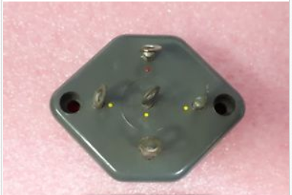

**DC Link Capacitors:** 470 uF, 330uF 400 V

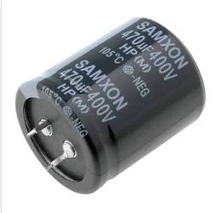

**IGBT :** IXGH 30N60C2 ( 600V , 70 A)

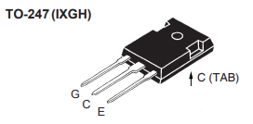

**Diode:** IXYS DSEI30-06A

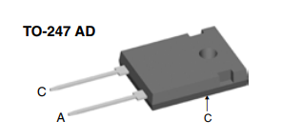

**Controller:** Arduino Nano

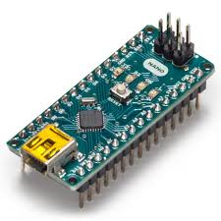

**Optocoupler**: It is required with IGBT gate driver

Vishay VO3120

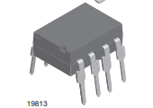

**Heat Sink:**

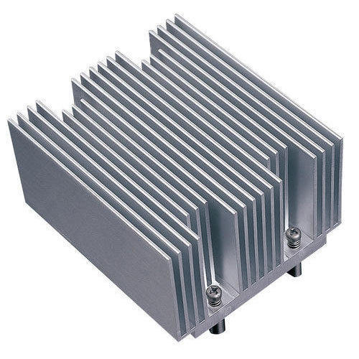

**Pertinaks**: 10cm *10 cm

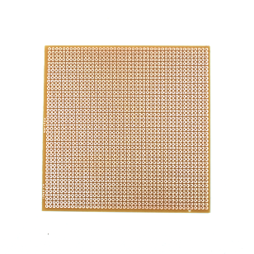

**Banana Connectors:**

